

Semester One Examination, 2014

Question/Answer Booklet

CHEMISTRY
Stage 3

Student Number: | In figures
 | In words

Time allowed for this paper

Reading time before commencing work: ten minutes
Working time for paper: three hours

Materials required/recommended for this paper

To be provided by the supervisor
This Question/Answer booklet
Multiple-choice Answer sheet
Chemistry Data sheet

To be provided by the candidate
Standard items: pens, pencils, eraser, correction fluid/tape, ruler, highlighters
Special items: non-programmable calculators satisfying the conditions set by the School Curriculum and Standards Authority for this course

Important note to candidates

No other items may be taken into the examination room. It is your responsibility to ensure that you do not have any unauthorised notes or other items of a non-personal nature in the examination room. If you have any unauthorised material with you, hand it to the supervisor before reading any further.

Structure of this paper

Section | Number of questions available | Number of questions to  be answered | Suggested  working time  (minutes) | Marks  available | Percentage  of exam
Section One:  Multiple-choice | 25 | 25 | 50 | 25 | 25
Section Two:  Short answer | 12 | 12 | 60 | 70 | 35
Section Three:  Extended  answer | 6 | 6 | 70 | 80 | 40
 |  |  |  | Total | 100

Instructions to candidates

1. The rules for the conduct of Western Australian external examinations are detailed in the Student Information Handbook 2014. Sitting this examination implies that you agree to abide by these rules.

2. Answer the questions according to the following instructions.

Section One: Answer all questions on the separate Multiple-choice Answer Sheet
provided. For each question shade the box to indicate your answer. Use only a blue or
black pen to shade the boxes. If you make a mistake, place a cross through that square then shade your new answer. Do not erase or use correction fluid or tape. Marks will not be deducted for incorrect answers. No marks will be given if more than one answer is completed for any question.

Sections Two and Three: Write your answers in this Question/Answer Booklet.

3. When calculating numerical answers, show your working or reasoning clearly. Express numerical answers to three significant figures and include appropriate units where applicable.

4. You must be careful to confine your responses to the specific questions asked and to follow any instructions that are specific to a particular question.

5. Spare pages are included at the end of this booklet. They can be used for planning your responses and/or as additional space if required to continue an answer.
• Planning: If you use the spare pages in planning, indicate this clearly at the top of the
page.
• Continuing an answer: If you need to use the space to continue an answer, indicate in
the original answer space where the answer is continued, i.e. give the page number.
Fill in the number of question(s) that you are continuing to answer at the top of the page.
Section One: Multiple-choice 25% (25 Marks)

This section has 25 questions. Answer all questions on the Multiple-choice Answer Sheet provided. Use only blue or black pen to shade the boxes. If you make a mistake, place a cross through that square. Do not erase or use correction fluid. Marks will not be deducted for incorrect answers. No marks will be given if more than one answer is given for any question.

Suggested working time: 50 minutes.
___________________________________________________________________________

- Which of the following best describes the molecular shape and molecular polarity of a chloroform molecule whose formula is CHC₃?

A. pyramidal, non-polar
B. tetrahedral, non-polar
C. pyramidal, polar
D. tetrahedral, polar

2. An element X has the following five successive ionisation energies (in kJ mol⁻¹)
680 1600 8000 11600 14500
What would be the formula of the compound formed when “X” reacts with oxygen?

A. XO
B. X₂O
C. X₂O₃
D. XO₂

3. Which of the following physical properties decrease with increasing atomic number for both the alkali metals and the halogens?

I Atomic radius
II Ionisation energy
III Melting point

A. II only
B. I and II only
C. I, II and III
D. I and III only

4. Which one of the following solids contains ionic and covalent bonds?

A. H₂O
B. MgO
C. NH₄Br
D. Ne

5. A crystal of iodine, I₂, produces a purple vapour when gently heated. Which pair of
statements correctly describes this process?

 | Type of bond broken | Formula of purple vapour
A. | covalent | I
B. | covalent | I₂
C. | dispersion forces | I₂
D. | dipole-dipole | I₂

6. Which of the following statements is correct?

A. Covalent network solids have strong van der Waal’s forces between atoms.
B. Metal solids exhibit non-directional inter-particle bonding.
C. Ionic solids conduct electricity very well in the aqueous and solid states.
D. Covalent molecular solids tend to decompose before melting.

7. Which of the following has a different number of electrons from the other three?

A. O₃
B. Sc³⁺
C. C₂H₆
D. CH₃F

8. Hydrogen bromide has a low melting point because it consists of

A. oppositely charged ions bonded by weak electrostatic attractive forces
B. positive ions electrostatically attracted to delocalised electrons
C. non-metal atoms covalently linked in a lattice
D. molecules linked by weak intermolecular attractive forces.

9. Tungsten, one of the transition metals, has a very high melting point but not as high as carbon in the form of diamond. This is best explained by:

A. Diamond has greater dispersion forces between its atoms than tungsten.
B. The covalent bonding present between diamond’s carbon atoms is stronger than
the metallic bonding in tungsten.
C. Tungsten has fewer valence electrons than carbon, so the less delocalised
electrons create the lower melting point.
D. Diamond’s molecules are polar, and the dipole-dipole attraction in diamond is
stronger than the metallic bonding in tungsten.

10. Consider the following potential energy diagram for a chemical reaction.
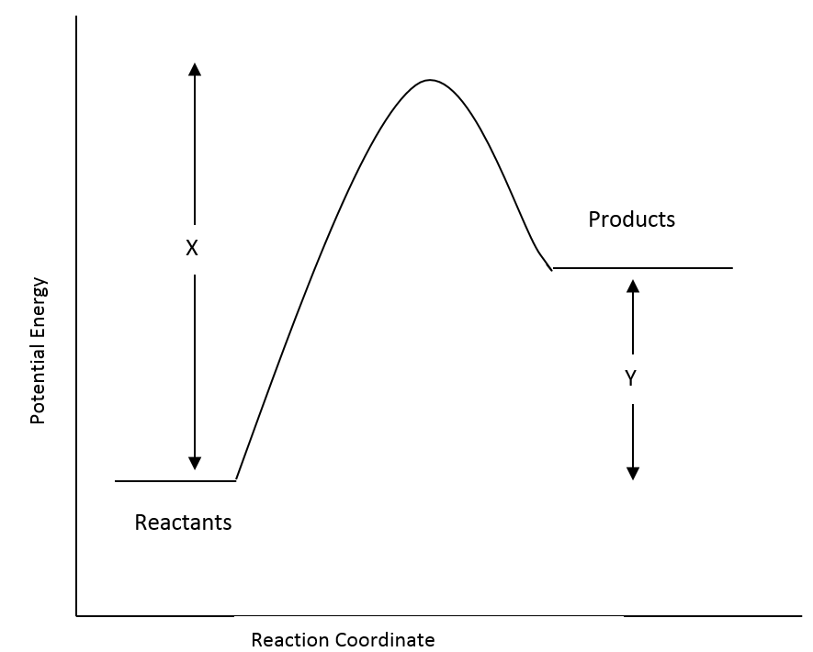

Which one of the following statements about this reaction is incorrect?

A. The reaction mixture will become hotter as the reaction proceeds.
B. The activation energy for the reverse reaction is (X–Y).
C. ΔH for the reverse reaction is −Y.
D. The forward reaction rate is likely to be slower than the reverse reaction rate.

11. HC, HBr and HI have boiling points of −85 ºC, −67 ºC and −35 ºC, respectively. The
best explanation for this trend in boiling points is:

A. The strength of hydrogen bonds increases as they progress down a column of
the Periodic Table.
B. The molecules HC, HBr and HI show increasing polarity.
C. The strength of dispersion forces increases as the number of electrons in a
molecule increases.
D. The strength of hydrogen bonds decreases as the number of electrons in a
molecule increases.

12. In the process for the preparation of methane:

C(s) + 2 H₂(g) ⇄ CH₄(g) ∆H = −75 kJ mol⁻¹

If the equilibrium system temperature is increased, what effect will this have on the
equilibrium constant, K, and the yield of CH₄?

 | Equilibrium constant, K | Yield of CH₄
A. | decrease | increase
B. | decrease | decrease
C. | increase | increase
D. | increase | decrease

13. The equilibrium constant, K, for the reaction,

2 H₂(g) + O₂(g) ⇄ 2 H₂O(g) is equal to 2 x 10⁸¹ at 25 ºC.

This value suggests that:

A. this reaction favours the forward reaction slightly more than the reverse reaction.
B. this reaction favours the reverse reaction slightly more than the forward reaction.
C. this reaction virtually goes to completion with little reversal.
D. this reaction virtually does not proceed forward and largely favours the reactants.

Questions 14 and 15 refer to the following four substances.

 | Name | Structure
I | hydroxylamine | 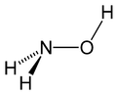
II | methanol | 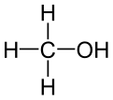
III | methoxymethane | 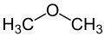
IV | ethyl ethanoate | 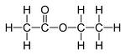

14. In which of the above substances would you expect hydrogen bonding to be present between their molecules?

A. All of them
B. I, II and III
C. I and II
D. II and IV

15. Which is the only one of the above molecules that has a trigonal planar arrangement of
atoms around one of the atoms in the molecule?

A. hydroxylamine
B. methanol
C. methoxymethane
D. ethyl ethanoate

16. A row of test tubes containing iron (III) ions, thiocyanate ions (SCN⁻) and the complex ion iron (III) thiocyanate (Fe(SCN)²⁺) are set up and allowed to come to equilibrium.

The equilibrium equation is:

Fe³⁺(aq) + SCN⁻(aq) ⇄ Fe(SCN)²⁺(aq) + HEAT
yellow colourless red

The test tubes appear orange due to the relative colours of the three ions.
Which of the following changes would not be expected to occur in association with the
change described in the table below? (Note: AgSCN is insoluble)

 | Imposed change | Colour at the new equilibrium
A. | Some NaSCN(s) is added and it dissolves into its ions. | Solution becomes more red.
B. | Some AgNO₃(s) is added, it dissolves and a white solid AgSCN forms. | Solution becomes more red.
C. | Some NaOH(s) is added, it dissolves and a brown solid forms. | Solution becomes more yellow.
D. | A test tube of the mixture is heated to near boiling point. | Solution becomes more yellow.

The next two questions, 17 and 18, refer to the following information:

Methanol is made commercially by pumping a mixture of carbon monoxide and hydrogen through a reaction chamber containing ZnO and Cr₂O₃. The equilibrium equation for the reaction is:

CO(g) + 2 H₂(g) ⇄ CH₃OH(g) ΔH = −91 kJ mol⁻¹

17. Which of the following conditions would favour the highest yield of the product methanol?

A. low temperature and high pressure.
B. low temperature and low pressure.
C. high temperature and low pressure.
D. high temperature and high pressure.

18. What is the likely function of the ZnO and Cr₂O₃?

A. These conduct away the heat and help favour the forward reaction.
B. These absorb the alcohol formed so it can be evaporated off later.
C. These transition metal oxides lower the ΔH of the reaction making it go faster.
D. These may be catalysts that enable equilibrium to be achieved faster.

19. Consider the reaction between 1.00 g of lithium carbonate powder and 100.0 mL of
0.200 mol L^{–1} ethanoic acid. Which of the following changes would result in an
increase in the initial rate of reaction?

A. Change the lithium carbonate powder to a single lump.
B. Change from 0.200 mol L^{–1} ethanoic acid to 0.200 mol L^{–1} hydrochloric acid.
C. Change from 100.0 mL of ethanoic acid to 200.0 mL of ethanoic acid.
D. Increase the pressure.

20. The substances pentane, propan-1-ol and propanone have the following structural formulae

pentane
propan-1-ol
propanone

Which of the following lists pentane, propan-1-ol and propanone in order of decreasing solubility in water?

A. pentane > propanone > propan-1-ol
B. propanone > pentane > propan-1-ol
C. propan-1-ol > pentane > propanone
D. propan-1-ol > propanone > pentane

21. A catalyst

A. lowers the activation energy of a given reaction.
B. speeds up a reaction but does not take part in the reaction.
C. creates a new pathway for the reaction.
D. lowers the ΔH of the reaction making it easier to achieve.

22. Which is the correct equilibrium constant expression for the following equation?

3 Fe(s) + 4 H₂O(g) ⇄ Fe₃O₄(s) + 4 H₂(g)

A. [Fe₃O₄] [H₂]
[Fe] [H₂O]

B. [Fe₃O₄] [H₂]⁴
[Fe]³ [H₂O]

C. [Fe₃O₄] + 4[H₂]
3 [Fe] + 4[H₂O]

D. [H₂]⁴
[H₂O]⁴

23. Consider the equilibrium established in the formation of phosphorous pentoxide:

P₄(s) + O₂(g) ⇄ P₄O₁₀(s) ΔH = –ve

Which of the following changes would lead to a new equilibrium with a change in the
concentration of O₂?

A. Addition of P₄(s)
B. Decreasing the surface area of P₄O₁₀(s)
C. Addition of O₂(g) at constant volume.
D. Decreasing the temperature at constant volume.

24. Which of the following correctly identifies the trends in atomic radii, first ionisation
energy and electronegativity as you go across period 3 from Na to C?

 | Atomic radii | First ionisation energy | Electronegativity
A. | decreases | increases | increases
B. | increases | decreases | increases
C. | decreases | increases | decreases
D. | increases | decreases | decreases

Question 25 refers to the following information:

Lecithin is a phospholipid found in egg yolks. It is used in the making of mayonnaise because it helps to form a stable oil/water suspension (a homogeneous mixture). It is interesting in that it is a bipolar molecule with a negatively charged oxygen atom and positively charged nitrogen atom found within the overall neutral molecule. An organic chemist wishing to show its structure might show it as in the diagram below:

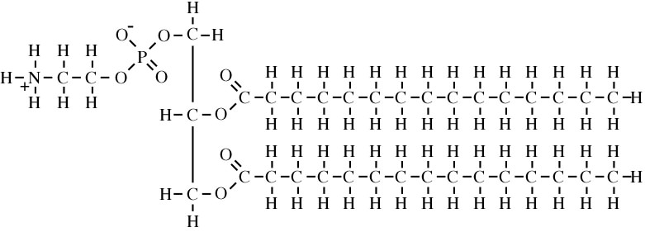

25. Given that oil contains non-polar molecules, what part(s) of the structure of lecithin
enable it to form the stable oil/water suspension?

A. The bottom part of the molecule bonds with water droplets and the long
hydrocarbon top parts bond with oil.
B. The charged parts of the molecule and the oxygen atoms throughout the molecule
bond with water and the carbon/hydrogen parts of it bond with the oil.
C. The positive nitrogen atom bonds with water and the negative oxygen atom bonds
with the oil.
D. The positive nitrogen atoms bond with oil and the negative oxygen atom bonds
with water.

End of Section One

Section Two: Short Answer 35% (70 Marks)

This section has twelve (12) questions. Answer all questions. Write your answers in the space provided.

Spare pages are included at the end of this booklet. They can be used for planning your responses and/or as additional space if required to continue an answer.
• Planning: If you use the spare pages for planning, indicate this clearly at the top of the page
• Continuing an answer: If you need to use the space to continue an answer, indicate in the original answer space where the answer is continued, i.e. give the page number. Fill in the number of the question(s) that you are continuing to answer at the top of the page.

Suggested working time: 60 minutes
___________________________________________________________________________

Question 26 (10 marks)

Consider the following system:
CO(g) + 2 H₂(g) ⇄ CH₃OH(g)
(a) At 25 ºC, K = 2.34 x 10⁻¹. At 58 ºC, K = 4.56 x 10⁻².
(4 marks)

Is the forward reaction exothermic or endothermic? ____________________________

Explain your answer:

______________________________________________________________________

______________________________________________________________________

______________________________________________________________________

______________________________________________________________________

______________________________________________________________________

______________________________________________________________________

______________________________________________________________________

(b) Predict whether the following changes will increase, decrease or have no effect on both
the forward rate and the equilibrium yield. (6 marks)
Change | Effect on rate | Effect on yield
Increasing the pressure of the system
Adding a catalyst
Decreasing the temperature |  | q

Question 27 (8 marks)

Phenolphthalein is a diprotic acid molecule (H₂PhTh ) and has two different equilibrium situations which are sensitive to concentrations of OH–(aq). In the pH range less than or equal to 8.3 the molecular form is in high concentration. There is no evidence of the first ionisation step which would forming H₃O⁺(aq) and the pink coloured ion, HPhTh–(aq).

If the phenolphthalein molecule is written as H₂PhTh, then the equilibrium equation for the first ionisation of phenolphthalein could be written as:

H₂PhTh(aq) + H₂O(l) ⇄ HPhTh–(aq) + H₃O⁺(aq) ΔH = +ve
colourless pink

(a) From the information given above, is the K value for the equation as written going to be
high or low? Explain your answer.
(2 marks)
______________________________________________________________________

______________________________________________________________________

______________________________________________________________________

______________________________________________________________________

(b) The following changes are imposed on a particular solution of phenolphthalein at equilibrium, which has a pale pink colour. Each change is made to a separate test tube and equilibrium is re-established.

Complete the table below, indicating the effect on the concentration of HPhTh–(aq) and the value of K. Use terms ‘increase’, ‘decrease’ or ‘no change’.

Also describe what you would observe as equilibrium is re-established in the system.
(6 marks)

Imposed change | Effect on  [HPhTh–] | Effect on K | Observation
HC(g) is bubbled
through the solution
The solution
is heated

Question 28 (10 marks)

A particular industrial process involves the steps shown on the diagram below.

Reaction 1 proceeds to completion but reaction 2 reaches equilibrium and has a high activation energy.

The product of the industrial process, D, passes through a membrane in the separation chamber which is impermeable (resistant) to B and C.

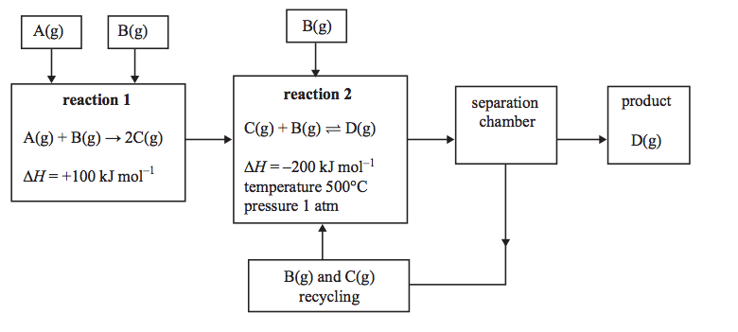
Note: 1 atm = 101.3 kPa

(a) D is removed from the system in the separation chamber at t₁.

(i) Sketch graphs on the axes below showing how this affect the rates of the forward and reverse reactions. Continue your graph until equilibrium has been re-established at t₂.
(3 marks)

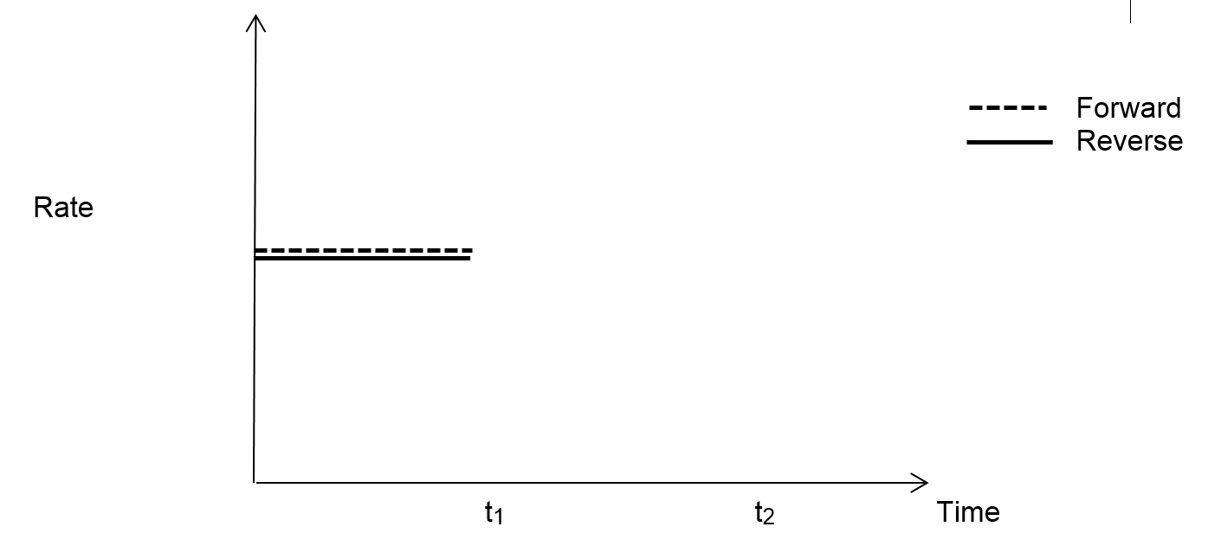

(ii) Explain the changes in rates of the forward and reverse reactions.
(4 marks)

______________________________________________________________________

______________________________________________________________________

______________________________________________________________________

______________________________________________________________________

______________________________________________________________________

______________________________________________________________________

______________________________________________________________________

______________________________________________________________________

______________________________________________________________________

______________________________________________________________________

______________________________________________________________________

______________________________________________________________________

(b) In practice the industrial process gives a poor yield of product D. As the equilibrium mixture of reaction 2 moves into the separation chamber, what changes would you make to the conditions to increase the yield of D?
(No explanations are required) (3 marks)

______________________________________________________________________

______________________________________________________________________

______________________________________________________________________

______________________________________________________________________

______________________________________________________________________

______________________________________________________________________

Question 29 (4 marks)

Write the equation for the reaction that occurs in each of the following procedures. If no reaction occurs, write ‘no reaction’. For full marks, chemical equations should refer only to those species consumed in the reaction and the new species produced. These species may be ions [for example Ag⁺(aq)], molecules [for example NH₃(g), NH₃(aq), CH₃COOH(l)] or solids [for example BaSO₄(s), Cu(s), Na₂CO₃(s)].

(a) Sodium hydrogencarbonate solution is mixed with hydrochloric acid solution. (2 marks)

Equation: ___________________________________________________________________

(b) Barium nitrate solution is mixed with sulfuric acid solution. (2 marks)

Equation: ___________________________________________________________________

Question 30 (6 marks)

Write observations for any reactions that occur in the following procedures (a) and (b).
In each case describe in full what you would observe, including any:
- colours;
- odours;
- precipitates (give the colour); and
- gases evolved (give the colour or describe as colourless).

If no change is observed, then you should state this.

(a) Excess hydrochloric acid is added to copper (II) carbonate solid. (2 marks)

Observation: _________________________________________________________________

___________________________________________________________________________

(b) Excess iron (II) nitrate solution is mixed with sodium hydroxide solution. (2 marks)

Observation: _________________________________________________________________

___________________________________________________________________________

(c) Write full observations for this reaction: (2 marks)
Cu(s) + 4 H⁺(aq) + 2 NO₃⁻(aq) Cu²⁺(aq) + 2 H₂O(l) + 2 NO₂(g)

Observation: _________________________________________________________________

___________________________________________________________________________

Question 31 (5 marks)

What is the pH of a mixture resulting from the addition of 500 mL of 0.10 mol L^{–1} NaOH and
750 mL of 0.050 mol L^{–1} HC?

___________________________________________________________________________

___________________________________________________________________________

___________________________________________________________________________

___________________________________________________________________________

___________________________________________________________________________

___________________________________________________________________________

___________________________________________________________________________

___________________________________________________________________________

___________________________________________________________________________

___________________________________________________________________________

___________________________________________________________________________

___________________________________________________________________________

Question 32 (6 marks)

For each species listed in the table below, draw Lewis structures, representing all valence shell electron pairs either as : or as — and state or draw the shape of the molecule or ion.

Molecule or ion | Lewis structure | Shape
H₂CO
SO₃²⁻
CS₂

Question 33 (3 marks)

The hydrogen phosphate ion, HPO₄^{2–}(aq), is an unusual ion in that it can stabilise solutions by reacting with both small acid changes and small alkaline changes and help keep the pH at a near neutral position.

(a) What is the term used to describe this action of the hydrogen phosphate ion?
(1 mark)
___________________________________

(b) Write equations showing how this ion responds to a small addition of:
(2 marks)

(i) dilute hydrochloric acid ____________________________________________

(ii) dilute potassium hydroxide _________________________________________

Question 34 (5 marks)

The diagram below shows the energy distribution curve for a gaseous reaction at 25 ºC. The activation energy for the uncatalysed reaction is also indicated.

(a) Redraw the redraw the distribution curve for a temperature of 68 ºC. (1 mark)
(b) Show on the diagram the activation energy for the catalysed reaction. (1 mark)

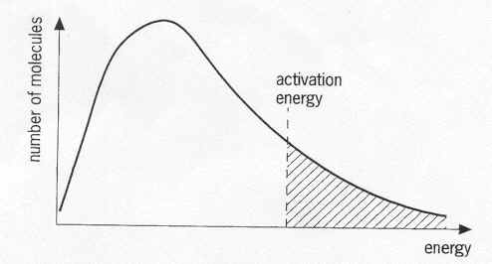
(c) Explain, using the above diagram, how the rate of reaction is affected with increased temperature and addition of a catalyst. (3 marks)

______________________________________________________________________

______________________________________________________________________

______________________________________________________________________

______________________________________________________________________

______________________________________________________________________

______________________________________________________________________

______________________________________________________________________

______________________________________________________________________

______________________________________________________________________

______________________________________________________________________

______________________________________________________________________

______________________________________________________________________

Question 35 (4 marks)

Chlorine forms two compounds, sodium chloride and carbon tetrachloride. Some of their properties are:
- sodium chloride melts at 801 ºC, boils at 1465 ºC and is a good conductor as a liquid.
- carbon tetrachloride melts at -23 ºC, boils at 77 ºC and is a very poor conductor as a liquid.

(a) Explain these differences in the melting and boiling points in terms of their chemical
bonding. (2 marks)

______________________________________________________________________

______________________________________________________________________

______________________________________________________________________

______________________________________________________________________

______________________________________________________________________

(b) Explain the differences in their electrical conductivity in terms of their chemical bonding.
(2 marks)

______________________________________________________________________

______________________________________________________________________

______________________________________________________________________

______________________________________________________________________

______________________________________________________________________

Question 36 (3 marks)

It was found that glue stuck on a desk was removed using ethanol but not hexane. By considering the structures of these molecules offer an explanation as to why the glue was soluble in one solvent but not the other.
Ethanol | Hexane

___________________________________________________________________________

___________________________________________________________________________

___________________________________________________________________________

___________________________________________________________________________

___________________________________________________________________________

Question 37 (6 marks)

The following salt solutions were tested with litmus indicator. Litmus is a solution that becomes a red colour in solutions below pH 7 and turns blue when in solutions above pH 7. Complete the table by indicating the colour change, if any, and write equations to support your conclusion.

Solution | Observation |  | Equation
 | with red litmus | with blue litmus
NaCH₃COO
NH₄NO₃

End of Section Two

Section Three: Extended answer 40% (80 Marks)

This section contains six (6) questions. You must answer all questions. Write your answers in the spaces provided.

Where questions require an explanation and/or description, marks are awarded for the relevant chemical content and also for coherence and clarity of expression. Lists or dot points are unlikely to gain full marks.

Final answers to calculations should be expressed to three (3) significant figures.

Spare pages are included at the end of this booklet. They can be used for planning your responses and/or as additional space if required to continue an answer.
• Planning: If you use the spare pages for planning, indicate this clearly at the top of the page.
• Continuing an answer: If you need to use the space to continue an answer, indicate in the original answer space where the answer is continued, i.e. give the page number. Fill in the number of the question(s) that you are continuing to answer at the top of the page.

Suggested working time: 70 minutes.
___________________________________________________________________________

Question 38 (22 marks)

The second stage in the manufacture of sulfuric acid via the Contact Process involves the oxidation of sulfur dioxide into sulfur trioxide.

2 SO₂(g) + O₂(g) ⇄ 2 SO₃(g) ΔH = −190 kJ mol⁻¹

The above reaction is at equilibrium and some changes were made to the system. The graph below represents the changes made at t₁, t₂, and t₃.
(The system re-establishes equilibrium before each new change is made)
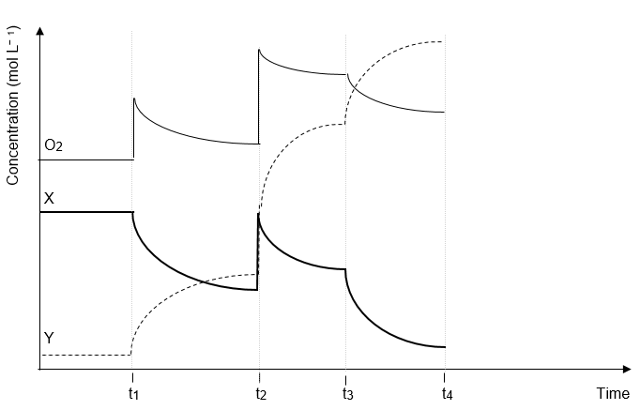

(a) (i) Based on the change that took place at t₁ it follows that:

X = __________ and Y = __________ (1 mark)

(ii) State what change is likely to have occurred at: (3 marks)

t₁ ______________________________________________________________

t₂ ______________________________________________________________

t₃ ______________________________________________________________

(iii) At t₄, a catalyst, vanadium pentoxide (V₂O₅), is added to the system.
Continue the graphs to represent the changes in concentration of the three
gases when a catalyst is added. (1 mark)

Question 38 continued

(b) In the Contact Process, it is important to maximise both the yield of SO₃ and the rate of
reaction. Use your knowledge of equilibrium and rates to predict and explain the optimum conditions of temperature and pressure for production of SO₃.

The equation for the production of SO₃ is repeated below:

2 SO₂(g) + O₂(g) ⇄ 2 SO₃(g) ΔH = −190 kJ mol⁻¹
(7 marks)

______________________________________________________________________

______________________________________________________________________

______________________________________________________________________

______________________________________________________________________

______________________________________________________________________

______________________________________________________________________

______________________________________________________________________

______________________________________________________________________

______________________________________________________________________

______________________________________________________________________

______________________________________________________________________

______________________________________________________________________

______________________________________________________________________

______________________________________________________________________

______________________________________________________________________

______________________________________________________________________

______________________________________________________________________

______________________________________________________________________

The full manufacture of sulfuric acid can be summarised in four main steps.

Step 1 Mining of “pyrite ore”, which contains, by mass, 73.00% FeS₂.

Step 2 Roasting of the ore to convert the sulfur into sulfur dioxide

4 FeS₂(s) + 11 O₂(g) 2 Fe₂O₃(s) + 8 SO₂(g)

Step 3 The oxidation of sulfur dioxide, which is only 68.00% efficient.

2 SO₂(g) + O₂(g) ⇄ 2 SO₃(g)

Step 4 Reaction of sulfur trioxide with water to form sulfuric acid

SO₃(g) + H₂O(l) H₂SO₄(aq)

(c) Calculate the mass of sulfuric acid that can be produced from 1.000 tonne (1000 kg) of “pyrite ore”. (You may assume that all other reactions are 100% efficient)
(7 marks)

______________________________________________________________________

______________________________________________________________________

______________________________________________________________________

______________________________________________________________________

______________________________________________________________________

______________________________________________________________________

______________________________________________________________________

______________________________________________________________________

______________________________________________________________________

______________________________________________________________________

______________________________________________________________________

______________________________________________________________________

______________________________________________________________________

______________________________________________________________________

______________________________________________________________________

Question 38 continued

(d) The commercial concentrated sulfuric acid produced by this process has a
concentration of 18.00 mol L⁻¹. Using your answer to (c), what volume of this acid
can be formed? Give your answer to four (4) significant figures.
(3 marks)

______________________________________________________________________

______________________________________________________________________

______________________________________________________________________

______________________________________________________________________

______________________________________________________________________

______________________________________________________________________

______________________________________________________________________

______________________________________________________________________

______________________________________________________________________

This page is intentionally blank

Question 39 (13 marks)

This question concerns the three elements sodium, potassium and magnesium.

(a) Write equations to represent the first and seventh ionisation energies of sodium.
(2 marks)

1st I.E. ________________________________________________________________

7th I.E. ________________________________________________________________

(b) Sketch a graph to show the trend in all the ionisation energies of sodium.
(3 marks)

Energy

Ionisation energies

(c) Explain the shape of the above graph. (3 marks)

______________________________________________________________________

______________________________________________________________________

______________________________________________________________________

______________________________________________________________________

______________________________________________________________________

______________________________________________________________________

______________________________________________________________________

______________________________________________________________________

(d) Which will have the higher first ionisation energy, sodium or potassium? Explain.
(2 marks)

______________________________________________________________________

______________________________________________________________________

______________________________________________________________________

______________________________________________________________________

______________________________________________________________________

______________________________________________________________________

______________________________________________________________________

(e) Arrange the three elements (Na, K, Mg) in order of increasing electronegativity and explain your choice.
(3 marks)

Order: lowest _____________________________________________ highest

Explanation:

______________________________________________________________________

______________________________________________________________________

______________________________________________________________________

______________________________________________________________________

______________________________________________________________________

______________________________________________________________________

______________________________________________________________________

Question 40 (9 marks)

Alka-Seltzer is a water soluble medication that can treat acid indigestion in two ways; by neutralising stomach acid using sodium hydrogencarbonate and treating the associated pain by using aspirin (C₉H₈O₄). When Alka-Seltzer was developed in the early part of the twentieth century, it was found that the solubility of the active ingredients were improved if a reaction that gives off a gas took place when the tablet was added to water. Therefore solid citric acid (C₆H₈O₇) was added to the mixture to react with some of the sodium hydrogencarbonate.

The reaction causing the effervescence is

3 NaHCO₃(s) + C₆H₈O₇(aq) → Na₃C₆H₅O₇(aq) + 3 H₂O(l) + 3 CO₂(g)

The normal composition of one Alka-Seltzer tablet is

Sodium hydrogencarbonate 1700 mg
Aspirin 325 mg
Citric acid 300 mg

(a) One tablet of Alka-Seltzer is completely dissolved in 270.0 mL of water, and all the bubbling has stopped. Calculate the final concentration in mol L⁻¹ of

(i) sodium hydrogen carbonate (2 marks)

______________________________________________________________________

______________________________________________________________________

______________________________________________________________________

______________________________________________________________________
(ii) aspirin (2 marks)

______________________________________________________________________

______________________________________________________________________

______________________________________________________________________

______________________________________________________________________

(b) In the stomach, the normal concentration of hydrochloric acid is 0.160 mol L⁻¹. The volume of the acid in the stomach can be assumed to be 0.650 L. A stressed student, studying for her WACE Chemistry examination, eats a whole packet of biscuits, causing
her concentration of acid to rise to 0.200 mol L⁻¹. Calculate how many Alka-Seltzer
tablets she should take to reduce the level of acid back to normal.

3 NaHCO₃(s) + C₆H₈O₇(aq) → Na₃C₆H₅O₇(aq) + 3 H₂O(l) + 3 CO₂(g)
(5 marks)

______________________________________________________________________

______________________________________________________________________

______________________________________________________________________

______________________________________________________________________

______________________________________________________________________

______________________________________________________________________

______________________________________________________________________

______________________________________________________________________

______________________________________________________________________

______________________________________________________________________

______________________________________________________________________

______________________________________________________________________

______________________________________________________________________

______________________________________________________________________

______________________________________________________________________

______________________________________________________________________

Question 41 (13 marks)

An unusual hydrated sulfate compound containing both potassium and chromium (III) has the general formula
KCr(SO₄)x.yH₂O
where both ‘x’ and ‘y’ are both integers.

If 36.5 g of the pure, hydrated compound is treated with excess sodium carbonate solution it is found that 10.38 g of highly insoluble chromium(III) carbonate is precipitated.

(a) Determine the number of mole of chromium in the hydrated compound.
(2 marks)

______________________________________________________________________

______________________________________________________________________

______________________________________________________________________

______________________________________________________________________

______________________________________________________________________

______________________________________________________________________

(b) Determine the molar mass of the compound.
(2 marks)

______________________________________________________________________

______________________________________________________________________

______________________________________________________________________

______________________________________________________________________

______________________________________________________________________

______________________________________________________________________

A further 4.70 g sample of the compound is heated strongly to drive off the water of crystallisation. A constant mass of 2.665 g of anhydrous powder remains after several subsequent heatings.

(c) Calculate the values of ‘x’ and ‘y’ in the formula of the compound.
(9 marks)

______________________________________________________________________

______________________________________________________________________

______________________________________________________________________

______________________________________________________________________

______________________________________________________________________

______________________________________________________________________

______________________________________________________________________

______________________________________________________________________

______________________________________________________________________

______________________________________________________________________

______________________________________________________________________

______________________________________________________________________

______________________________________________________________________

______________________________________________________________________

______________________________________________________________________

______________________________________________________________________

Question 42 (15 marks)

An unknown amino acid, X, containing the elements C, H, N and O, was subjected to analysis in order to determine its formula.

1st experiment 2.07 g of X was completely burned in excess oxygen and 3.07 g of
carbon dioxide and 1.45 g of water were formed.
2nd experiment 1.68 g of X was reacted so as to convert all the nitrogen into nitrogen
gas (N₂). It was found that the gas formed occupied 211 mL, measured
at STP.
3rd experiment 1.39 g of X was vapourised at 200 ºC and 105 kPa and was found to
occupy a volume of 584 mL.

(a) Calculate the empirical formula of X.
(12 marks)

______________________________________________________________________

______________________________________________________________________

______________________________________________________________________

______________________________________________________________________

______________________________________________________________________

______________________________________________________________________

______________________________________________________________________

______________________________________________________________________

______________________________________________________________________

______________________________________________________________________

______________________________________________________________________

______________________________________________________________________

______________________________________________________________________

______________________________________________________________________

______________________________________________________________________

______________________________________________________________________

(b) Calculate the molecular formula of X. (3 marks)

______________________________________________________________________

______________________________________________________________________

______________________________________________________________________

______________________________________________________________________

______________________________________________________________________

______________________________________________________________________

______________________________________________________________________

______________________________________________________________________

Question 43 (8 marks)

A student investigated the equilibrium system involving brown nitrogen dioxide gas (NO₂) and colourless dinitrogen tetroxide as (N₂O₄).

2 NO₂(g) ⇄ N₂O₄(g)
brown colourless

Nitrogen dioxide gas was placed into a reaction chamber as shown and allowed to reach equilibrium
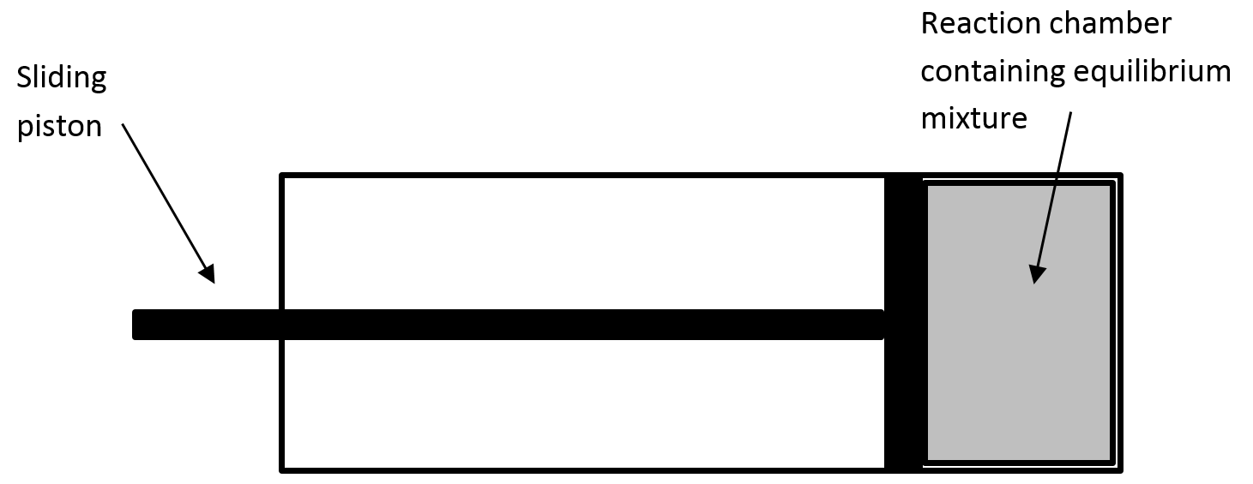

The colour of the mixture was compared under different reaction conditions.

Temperature (ºC) | Pressure (kPa) | Colour
0 | 100 | light brown
25 | 100 | brown
100 | 100 | dark brown

The graph represents the change in concentration of N₂O₄ as the reaction proceeds to equilibrium at 25 ºC. The ‘X’ on the concentration axis represents the initial concentration of NO₂(g).

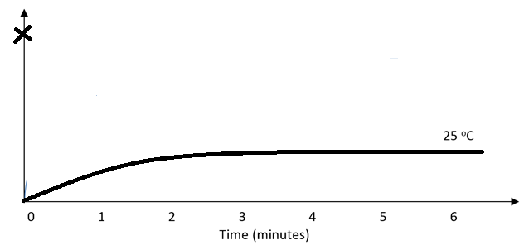

(a) Which reaction was favoured as the temperature increased? Explain your choice.
(2 marks)
______________________________________________________________________

______________________________________________________________________

______________________________________________________________________

______________________________________________________________________

______________________________________________________________________

______________________________________________________________________

(b) Is the forward reaction endothermic or exothermic? Explain your choice.
(2 marks)
______________________________________________________________________

______________________________________________________________________

______________________________________________________________________

______________________________________________________________________

______________________________________________________________________

______________________________________________________________________

(c) On the graph on the previous page, sketch a curve that represents the concentration of
NO₂(g) over the six minute period.
(2 marks)

(d) At what temperature were reactions in the equilibrium mixture occurring most quickly?
Explain why the rate of reaction was highest at this temperature.
(2 marks)
______________________________________________________________________

______________________________________________________________________

______________________________________________________________________

______________________________________________________________________

______________________________________________________________________

______________________________________________________________________

______________________________________________________________________

______________________________________________________________________

End of Examination
Additional working space

___________________________________________________________________________

___________________________________________________________________________

___________________________________________________________________________

___________________________________________________________________________

___________________________________________________________________________

___________________________________________________________________________

___________________________________________________________________________

___________________________________________________________________________

___________________________________________________________________________

___________________________________________________________________________

___________________________________________________________________________

___________________________________________________________________________

___________________________________________________________________________

___________________________________________________________________________

___________________________________________________________________________

___________________________________________________________________________

___________________________________________________________________________

___________________________________________________________________________

___________________________________________________________________________

___________________________________________________________________________

___________________________________________________________________________

___________________________________________________________________________

___________________________________________________________________________

___________________________________________________________________________

___________________________________________________________________________

___________________________________________________________________________

___________________________________________________________________________

Additional working space

___________________________________________________________________________

___________________________________________________________________________

___________________________________________________________________________

___________________________________________________________________________

___________________________________________________________________________

___________________________________________________________________________

___________________________________________________________________________

___________________________________________________________________________

___________________________________________________________________________

___________________________________________________________________________

___________________________________________________________________________

___________________________________________________________________________

___________________________________________________________________________

___________________________________________________________________________

___________________________________________________________________________

___________________________________________________________________________

___________________________________________________________________________

___________________________________________________________________________

___________________________________________________________________________

___________________________________________________________________________

___________________________________________________________________________

___________________________________________________________________________

___________________________________________________________________________

___________________________________________________________________________

___________________________________________________________________________

___________________________________________________________________________

___________________________________________________________________________

